Year 5 Answer sheet to Maths Home Learning– Week 2 – Mark with an adult if possible and email your class email address if you have any queries.
Day 6 – Area of Compound Shapes
 | Worksheet 1 - *
1 | Area a: 4cm2 | Area b : 10cm2 | Total =14cm2
2 | Area a : 4cm2 | Area b : 6cm2 | Total = 10cm2
3 | Area a: 10cm2 | Area b : 3cm2 | Total =13cm2
4 | Area a : 12cm2 | Area b : 24cm2 | Total = 36cm2
5 | Area a: 9cm2 | Area b : 10cm2 | Total =19cm2
6 | Area a 20cm2 | Area b : 18cm2 | Total = 38cm2
7 | Area a : 18cm2 | Area b : 12cm2 | Area c : 10cm2 | Total = 40cm2
8 | Area a : 8cm2 | Area b : 12cm2 | Area c : 10cm2 | Total = 30cm2
9 | Area a : 14cm2 | Area b : 15cm2 | Area c : 16cm2 | Total = 45cm2
10 | Area a : 16cm2 | Area b : 12cm2 | Area c : 15cm2 | Total = 43cm2

Day 7 – Area of Compound Shapes
1 | Total = 42cm2 | 6 | Total = 96cm2
2 | Total = 35cm2 | 7 | Total = 57cm2
3 | Total = 38cm2 | 8 | Total = 88cm2
4 | Total = 42cm2 | 9 | Total = 94cm2
5 | Total = 38cm2 | 10 | Total = 104cm2

Final Sheet – Have you meet the challenge?
1 | 87cm2 | 6 | 153cm2
2 | 34cm2 | 7 | 129cm2
3 | 65cm2 | 8 | 672cm2
4 | 66cm2 | 9 | 382cm2
5 | 112cm2

Day 8 & 9 – Area of Triangles
 | Worksheet * | Worksheet **
1 | 12cm2 | 20cm2
2 | 10cm2 | 12cm2
3 | 9cm2 | 31.5cm2
4 | 8cm2 | 40,5cm2
5 | 15cm2 | 18vm2
6 | 8cm2 | 14cm2
7 | 14cm2 | 18cm2
8 | 15cm2 | 33cm2
9 | 25cm2 | 6cm2
10 | 6cm2 | 17.5cm2

Day 10 – Standard International and Imperial Measures
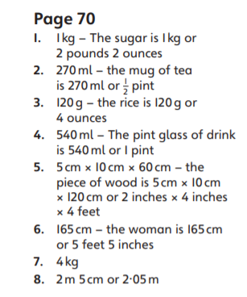
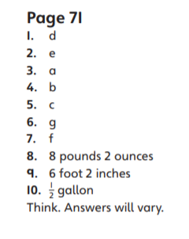

Which is right?
 | Worksheet * | Worksheet ** | Worksheet ***
1 | 0.8 inches | 4 inches | 50cm
2 | 12.5cm | 15 cm | 5 inches
3 | 300 g | 600 g | 180 g
4 | 2250 g | 2250 g | 4050 g
5 | 1.8 l | 9 l | 4.8 l
6 | 18 pints | 5.4 pints | 45 pints

