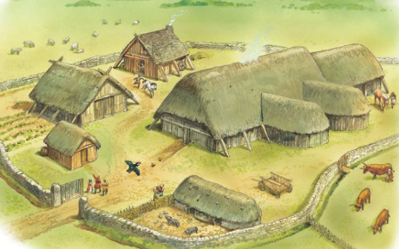
Class - WOODPECKERS Term 2 Who lives in a house like this?

English (Writing) | English  (SPAG) | Maths |  | Science |  | Geography
Diary entry  Recount of the Nativity | Past Tense  First person  Coordinating conjunctions  Subordinating conjunctions  Adverbials of time and place  Expanded noun phrases  Commas for fronted adverbials (Year4)  Apostrophes for omission and possession | Addition and subtraction  Add and subtract 3 digit numbers (4 digit numbers Year 4) using a column method  Multiplication and division  Multiply and divide by 2, 3, 4, 5, and 8  Year 4 – Multiply and divide by 3, 6, 7, 9, 11 and 12. Multiply and divide by 1 and 0.  Area – Year 4  What is area?  Count and make shapes  Compare area  Daily for all  Times Table Rock Star practise |  | Living things and their habitats  - recognise that living things can be grouped in a variety of ways  - explore and use classification keys to help group, identify and name a variety of living things in their local and wider environment  - recognise that environments can change and that this can sometimes pose dangers to living things |  | human geography, including: types of settlement and land use and economic activity done by the Vikings  Britain’s settlement by Anglo-Saxons and Scots and how this is seen today.  locate the world’s countries, using maps to focus on Europe to identify where the Viking’s came from
Art / D & T | Spanish | ICT | PSHE |  | RE | PE
D & T  Create a 3D model of a Viking Dwelling | ¿Dónde vives?  Saying your nationality  Saying which country you live in and which language you speak  Saying which language you don't speak, which country you don't live in and which nationality you aren't  Saying where you live, your nationality and which language you speak | Stop Frame Animation  Can a picture move?  Frame by frame  What’s the story  Picture perfect  Evaluate and make it great! | Celebrating difference  Families  Family conflict  Witness and feelings  Witness and solutions  Words that harm  Compliments |  | Christianity  What is it like for Christians to follow God?  What is the most significant part of the nativity story for Christians today? | Alternative sports – PH Sports  use running, jumping, throwing and catching in isolation and in combination  Hockey – Mr Herring  play competitive games, modified where appropriate and apply basic principles suitable for attacking and defending.
 |  |  |  |  |  | Music
Exploring sounds
• Learning how sounds are produced and how instruments are classified • Learning about aerophones • Understanding musical conversation structure
• Creating a call and response
Performance
• Enhancing and extending the performance of a poem using vocal patterns • Creating a piece of ‘playground music’ out of layered vocal patterns as part of a performance piece
• Exploring contrasting moods and effects as part of a performance
• Combining two rhythmic patterns using body percussion and percussion instruments as part of a performance piece

