Chaffinches Forest School 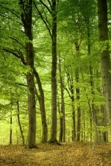
02nd May 2019
Dear Parents,
Chaffinches will be having a further 3 Forest School sessions in Term 5 on a Wednesday afternoon.
The weather is likely to be variable so please can you ensure your child has a change of clothes for the weather with suitable coat, hat, wellies or waterproof shoes, long sleeved top and trousers. If you have waterproof trousers for your child please can they bring these too. There is a strong possibility they will get dirty so don’t send them in anything nice! It is really important they have suitable clothing to ensure they can enjoy the experience.
If you would like to come and join us, even if it is just 1 session, then please let me know. Please sign and return the slip below and tick if you are able to join us.
Kind regards
Mrs Clare Pike
----------------------------------------------------------------------------------------
Child’s Name _____________________
I am able to help –
8th May | 15th May | 22nd May

Signed ___________________ Name __________________

