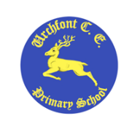
Urchfont CE Primary School – Long Term 2-year cycle Curriculum Plan for Robins Class

 | Main theme | Subsidiary subjects that will be taught with this theme
 |  | Science | DT | Other
Cycle A
Term 1 | Castles | Materials
Term 2 | Dinosaurs | Animals including Humans |  | Christmas Play
Term 3 | Italy | Seasonal Changes - Winter | Making Pizza
Term 4 | Our Local Area & School | Seasonal Changes – Spring
Term 5 | How does your garden grow? | Plants
Term 6 | People who help us – Florence Nightingale/ Mary Seacole | Seasonal Changes - Summer
Cycle B
Term 1 | The Poles – Artic | Seasonal Changes – Autumn  Plants
Term 2 | The Poles – Antarctic | Seasonal Changes - Winter |  | Christmas Play
Term 3 | Pirates | Floating & Sinking
Term 4 | Travel & Transport | Seasonal Changes – Spring  Forces/ Materials
Term 5 | What are little girls & boys made of? | Animals including Humans
Term 6 | The Seaside now & in the past | Seasonal Changes - Summer

