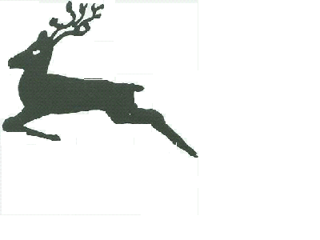
Urchfont C. E. Primary School
Cuckoo Corner, Urchfont, Devizes, Wiltshire, SN10 4RA
Tel: 01380 840793
Email: admin@urchfont.wilts.sch.uk

Cuckoo Corner
Urchfont
Devizes
SN10 4RA
3rd April 2020

Dear Parents,

Another term has come and gone and I can’t believe what we are experiencing! I certainly didn’t expect to be in the situation that we find ourselves in now, when we welcomed the children back to school in February – that seems like an eternity ago. I couldn’t end the term without writing to you – as I normally do and feel it is important to keep doing as many normal activities as possible.

We did manage a few activities this term, including World Book Day, which we celebrated with a wonderful Reading Breakfast. It was so lovely to see you all there and share this day with you. Mrs Pottinger managed a number of netball matches which we won – we are always so proud of our children when they represent the school and especially when they win! I hope the children remember Shrove Tuesday when we held our Pancake Races and we even managed to eat a few pancakes along the way, as well as destroying quite a few in the family races!

I would like to thank you all for your support and understanding during the last two weeks. The staff moved heaven and earth to produce the home learning packs for the children in the week before schools were closed. We knew school closures were coming but had no confirmed date. We hope the home learning packs will evolve and that more structure and guidance (if required), will be given in the following weeks. Like you, we hope this closure will only last for the minimum time required, but we are in the hands of the government and scientists. For the immediate future, I have instructed my staff not to go into school. This is deemed as unnecessary travel as we have no children for key workers or vulnerable children who require care at this time. Therefore, they are unable to photocopy any worksheets. However, we are hoping that restrictions might be lessened before the end of the Easter break and we might be able to produce a limited number of packs for children without internet access. For the vast majority of children, we are thinking that the work can be accessed on-line and any recording can then be done on paper. As you can imagine, these ideas are evolving as none of us have ever been in this situation before. We will, of course, inform you how we are going to proceed with home learning in the coming weeks.

May I wish you all, on behalf of the staff a lovely Easter break and hope to see you all very soon.

Yours sincerely
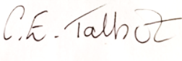
Mrs Carol Talbot
(Head Teacher)

