Name: Date:

In English this week I have been…
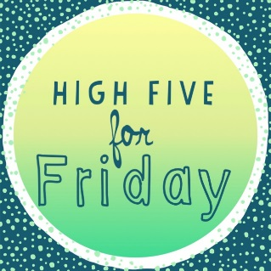
I am getting better at…

In maths this week I have been..

I was proud that I was able to…

The best part of my week with home schooling was…

Next week I would like to…

I got …/10 in my weekly spellings.

